  浙江大学信息与电子工程学院 | 集成电路原理与设计 | 2023年4月
Table 7.1
 |  | Typical Parameter Value
Parameter Symbol | Parameter Description | n-Channel | p-Channel | Units
V_{T0} | Threshold voltage(V_{BS}=0) | 0.7 | -0.8 | V
K | Transconductance parameter(in saturation) | 134 | 50 | μA/V²
γ | Bulk threshold parameter | 0.45 | 0.4 | V^{1/2}
λ | Channel length modulation parameter | 0.1 | 0.2 | V⁻¹
2|ϕ_{F}| | Surface potential at strong inversion | 0.9 | 0.8 | V
$$K=μC_{OX}$$
- Assume that W/L ratios of Figure 7.1 are (W/L)₁ = 2μm/1μm and (W/L)₂ = (W/L)₃ = (W/L)₄ =1μm/1μm. Find the dc value of v_{IN} that will give a dc current in M1 of 110μA. Calculate the small signal voltage gain and output resistance using the parameters of Table 7.1. Assume λ=γ=0.
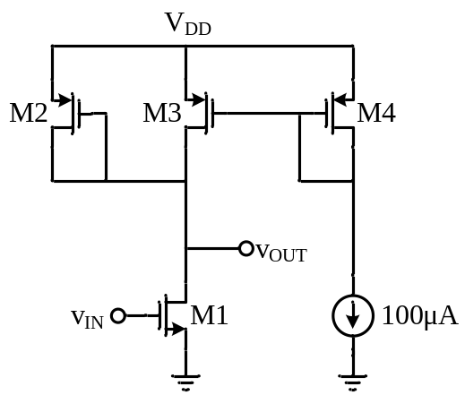
Figure 7.1

Answer:
$$I_{D1}=\frac{1}{2}K_{N}(\frac{W}{L})_{1}(V_{in}-V_{TH1})^{2} \\ 110μ=\frac{1}{2}×(134μ)×\frac{2}{1}×(V_{in}-0.7)^{2} \\ V_{in}=1.61V$$
$$I_{D3}=I_{D4}=100μA \\ I_{D2}=I_{D1}-I_{D3}=10μA \\ A_{v}≅-\frac{g_{m1}}{g_{m2}}=-\sqrt{\frac{K_{N}}{K_{P}}\frac{(W/L)_{1}}{(W/L)_{2}}\frac{I_{D1}}{I_{D2}}}=-\sqrt{\frac{134μ}{50μ}×\frac{2}{1}×\frac{110μ}{10μ}}=-7.68 \\ R_{out}≅\frac{1}{g_{m2}}=\frac{1}{\sqrt{2K_{P}(W/L)_{2}I_{D2}}}=\frac{1}{\sqrt{2×50×10^{-6}×1×10×10^{-6}}}=31.6KΩ$$

- Suppose the common-source stage of Fig 7.2 is to provide an output swing from 1V to 2.5V. Assume that (W/L)₁ = 50/0.5, R_{D} = 2kΩ, V_{DD} = 3V and λ = 0. Use model parameters in Table 7.1.
  - Calculate the input voltages that yield V_{out} = 1V and V_{out} = 2.5V.
  - Calculate the drain current and the transconductance of M₁ for both cases.
  - How much does the small-signal gain, g_{m}R_{D}, vary as the output goes from 1V to 2.5V?
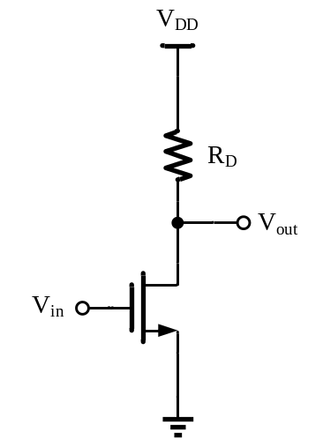

Figure 7.2
Answer:

a), b):

Vout=1V时：

$$I_{D1}=\frac{V_{DD}-V_{out}}{R_{D}}=1mA$$

$$V_{in}=V_{THN0}+\sqrt{\frac{2I_{D1}}{K_{N}{\left(\frac{W}{L}\right)}_{1}}}=1.086V$$

$g_{m1}=\sqrt{2K_{N}{\left(\frac{W}{L}\right)}_{1}I_{D}}=5.18×10^{-3}$S
Vout=2.5V时：
$$I_{D1}=\frac{V_{DD}-V_{out}}{R_{D}}=0.25mA$$
$$V_{in}=V_{THN0}+\sqrt{\frac{2I_{D1}}{K_{N}{\left(\frac{W}{L}\right)}_{1}}}=0.893V$$
$g_{m1}=\sqrt{2K_{N}{\left(\frac{W}{L}\right)}_{1}I_{D}}=2.588×10^{-3}$S

c)：
$$Δg_{m}R_{D}=5.18$$

- Consider the circuit of Fig 7.3 with (W/L)₁ = 50/0.5 and (W/L)₂ = 10/0.5. Assume that λ = γ = 0, V_{DD} = 3V.
- At what input voltage is M₁ at the edge of the triode region? What is the small-signal gain under this condition?
- When V_{out} is 0.66 V, what is the small-signal gain under this condition?
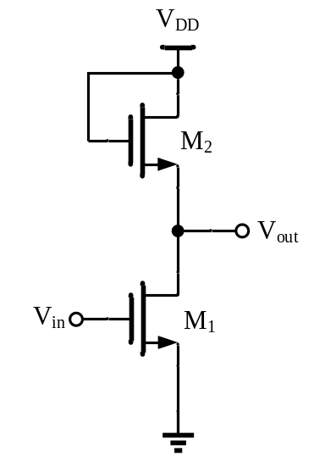

Figure 7.3

Answer:
a)
M₁ at the edge of the triode region：
$$V_{out}=V_{in}-V_{TH1}$$
$$I_{D1}=I_{D2}=\frac{1}{2}K_{N}{\left(\frac{W}{L}\right)}_{1}{\left(V_{in}-V_{TH1}\right)}^{2}=\frac{1}{2}K_{N}{\left(\frac{W}{L}\right)}_{2}{\left(V_{DD}-V_{out}-V_{TH2}\right)}^{2}$$
$V_{in}=1.41V$，$V_{out}=0.71V$
$$A_{V}=-\sqrt{\frac{2K_{N}{\left(\frac{W}{L}\right)}_{1}I_{D1}}{2K_{N}{\left(\frac{W}{L}\right)}_{2}I_{D2}}}=-2.236$$
b)
Vout=0.66V＜0.71V， M₁ is working in the triode region
$$\frac{1}{2}K_{N}{\left(\frac{W}{L}\right)}_{2}{\left(V_{DD}-V_{out}-V_{TH2}\right)}^{2}=K_{N}{\left(\frac{W}{L}\right)}_{1}\left[\left(V_{in}-V_{TH1}\right)V_{out}-\frac{V_{out}^{2}}{2}\right]$$
$$V_{in}=1.84V$$
$$I_{D}=K_{N}{\left(\frac{W}{L}\right)}_{1}\left[\left(V_{in}-V_{TH1}\right)V_{out}-\frac{V_{out}^{2}}{2}\right]$$
$$\frac{∂I_{D}}{∂V_{in}}=K_{N}{\left(\frac{W}{L}\right)}_{1}V_{out}$$
$$A_{V}=-\frac{g_{m1}}{g_{m2}}=-\frac{K_{N}{\left(\frac{W}{L}\right)}_{1}V_{out}}{K_{N}{\left(\frac{W}{L}\right)}_{2}\left(V_{DD}-V_{out}-V_{TH2}\right)}=-2.015$$

- In the circuit of Fig 7.4, (W/L)₁ = 20/0.5, I₁ = 1mA, and I_{S} = 0.75mA. Assuming λ = 0, V_{DD} = 3V, calculate (W/L)₂ such that M₁ is at the edge of triode region. What is the small-signal voltage gain under this condition? Use model parameters in Table 7.1.
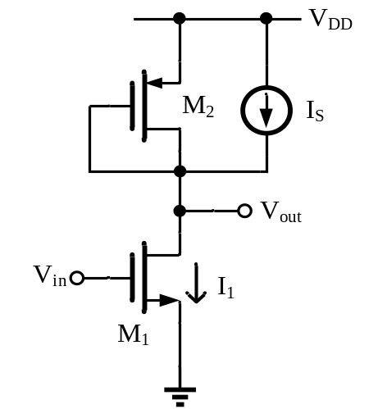

Figure 7.4

Answer:
M₁ at the edge of the triode region：
$$V_{out}=V_{in}-V_{TH1}$$
$$\frac{1}{2}K_{P}{\left(\frac{W}{L}\right)}_{2}{\left(V_{DD}-V_{out}-\left|V_{TH2}\right|\right)}^{2}+I_{S}=\frac{1}{2}K_{N}{\left(\frac{W}{L}\right)}_{1}{\left(V_{in}-V_{TH1}\right)}^{2}=10^{-3}$$
$V_{in}=1.311$，${\left(\frac{W}{L}\right)}_{2}=3.961$
$$A_{V}=-\frac{g_{m1}}{g_{m2}}=-\sqrt{\frac{K_{N}{\left(\frac{W}{L}\right)}_{1}I_{1}}{K_{P}{\left(\frac{W}{L}\right)}_{2}I_{2}}}=-10.4$$

- Consider the circuit of Fig 7.5 with (W/L)₁ = 50/0.5, R_{D} = 2kΩ, and R_{S} = 200Ω, V_{DD} = 3V. Use model parameters in Table 7.1.
a) Calculate the small-signal voltage gain if I_{D} = 0.5mA.
b) Assuming that λ = γ = 0, calculate the input voltage that places M1 at the edge of the triode region. What is the gain under this condition?

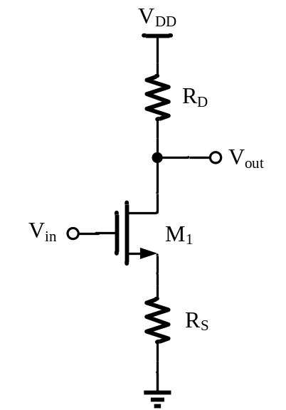

Figure 7.5

Answer:
a)：
$$V_{S}=R_{S}I_{D}=0.1V$$
$$V_{TH1}=V_{TH1,0}+γ\left(\sqrt{2\left|φ_{F}\right|+V_{SB}}-\sqrt{2\left|φ_{F}\right|}\right)=0.7+0.45\left(\sqrt{0.9+0.1}-\sqrt{0.9}\right)=0.723$$
$$V_{out}=V_{DD}-R_{D}I_{D}=2V$$
$$V_{DS}=2-0.1=1.9V$$
$$g_{m}=\sqrt{2K_{N}{\left(\frac{W}{L}\right)}_{1}\left(1+λV_{DS}\right)I_{D}}=3.993×10^{-3}$$
$$A_{V}=-\frac{g_{m}R_{D}}{1+g_{m}R_{S}}=-4.44$$
b):
M1 at the edge of the triode region
$$V_{out}=V_{in}-V_{TH1}$$
$$V_{in}=V_{GS1}+R_{S}I_{D}$$
$$V_{DD}-R_{D}I_{D}=V_{out}$$
$$V_{DD}-\left(R_{S}+R_{D}\right)I_{D}=V_{GS1}-V_{TH1}$$
$$I_{D}=\frac{1}{2}{K_{N}\left(\frac{W}{L}\right)}_{1}{\left(V_{GS1}-V_{TH1}\right)}^{2}=\frac{1}{2}K_{N}{\left(\frac{W}{L}\right)}_{1}{\left[V_{DD}-\left(R_{S}+R_{D}\right)I_{D}\right]}^{2}$$
$I_{D1}=1.58mA$（V_{GS}＜V_{TH}，eliminate），$I_{D2}=1.17mA$
$$V_{in}=V_{DD}-R_{D}I_{D}+V_{TH1}=1.36V$$
$$g_{m1}=\sqrt{2K_{N}{\left(\frac{W}{L}\right)}_{1}I_{D}}=5.60×10^{-3}$$
$$G_{m}=\frac{g_{m1}}{1+g_{m1}R_{S}}=2.642×10^{-3}$$
$$A_{V}=-G_{m}R_{D}=-5.283$$

